# Axis Design Site Plan

## Jacob Mo

## WDD 130

## Overview

### Purpose

The purpose of my website is to represent a **fictional** modern architecture firm called *Axis Design* and show off their work, design process, and overall style. It’s meant to give visitors a look into how the firm approaches modern, sustainable design and what kinds of projects they create.

### Audience

The audience for this site would mainly be people interested in architecture or design, as well as potential clients who want to see examples of the firm’s work before reaching out. The site focuses on clean visuals, simple navigation, and large imagery to match the professional and modern feel of the brand.

## Branding

### Website Logo

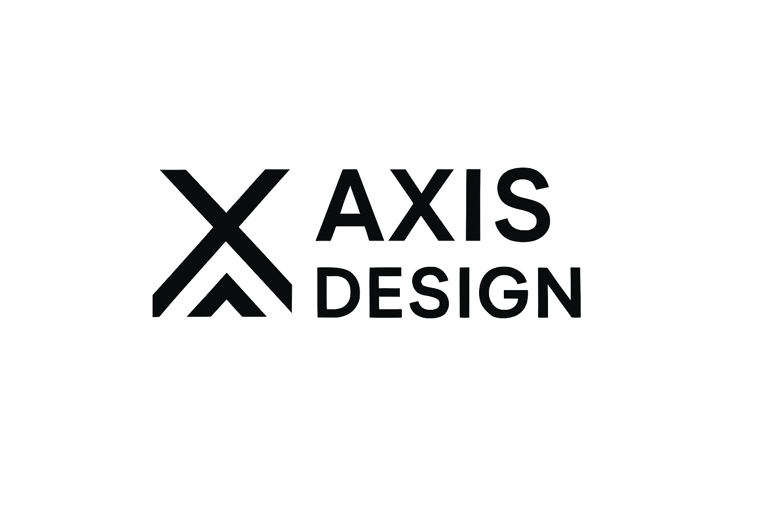

## Style Guide

### Color Palette

| Primary | Secondary | Accent 1 | Accent 2 |
| --- | --- | --- | --- |
| #0F0F0F | #FFFFFF | #ffda9d | #7f523b |
|  |  |  |  |

### Typography

#### Heading Font: Poppins (Medium)

#### Paragraph Font: Lato (normal)

### Navigation

Home Page 2 Page 3

hover ^ color

Content

[put all content for the pages here, including written text and images]

*Actual content will be Italicised*

* **Home page: (Photo spans the entire background and text is on top.)**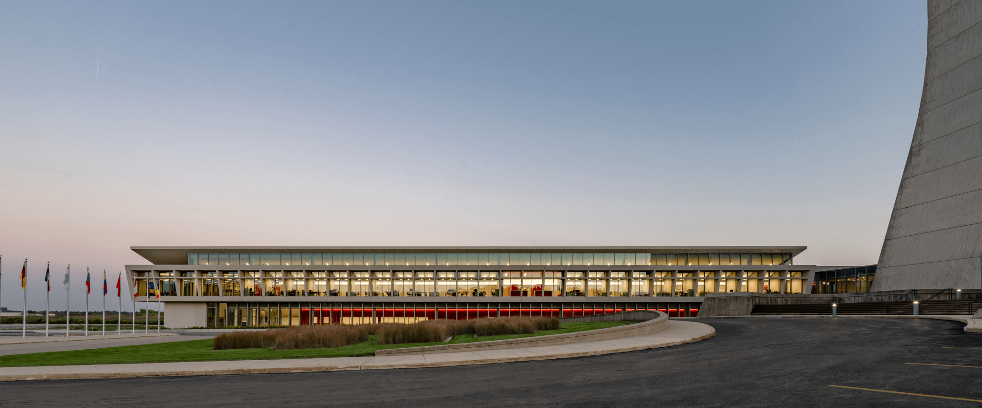
  + **Hero Section**
    - **Heading:** Designing the Future of Space
    - **Sub-heading:** Where Innovation, sustainability and form unite
    - **Button:** View our process
  + **About preview**
    - **Paragraph:** At Axis Design we believe architecture is more than building—it’s crafting environments that inspire and endure. From concept to completion we integrate modern aesthetics with eco-conscious materials, to deliver spaces that feel alive and timeless.
    - **Button:** Learn More

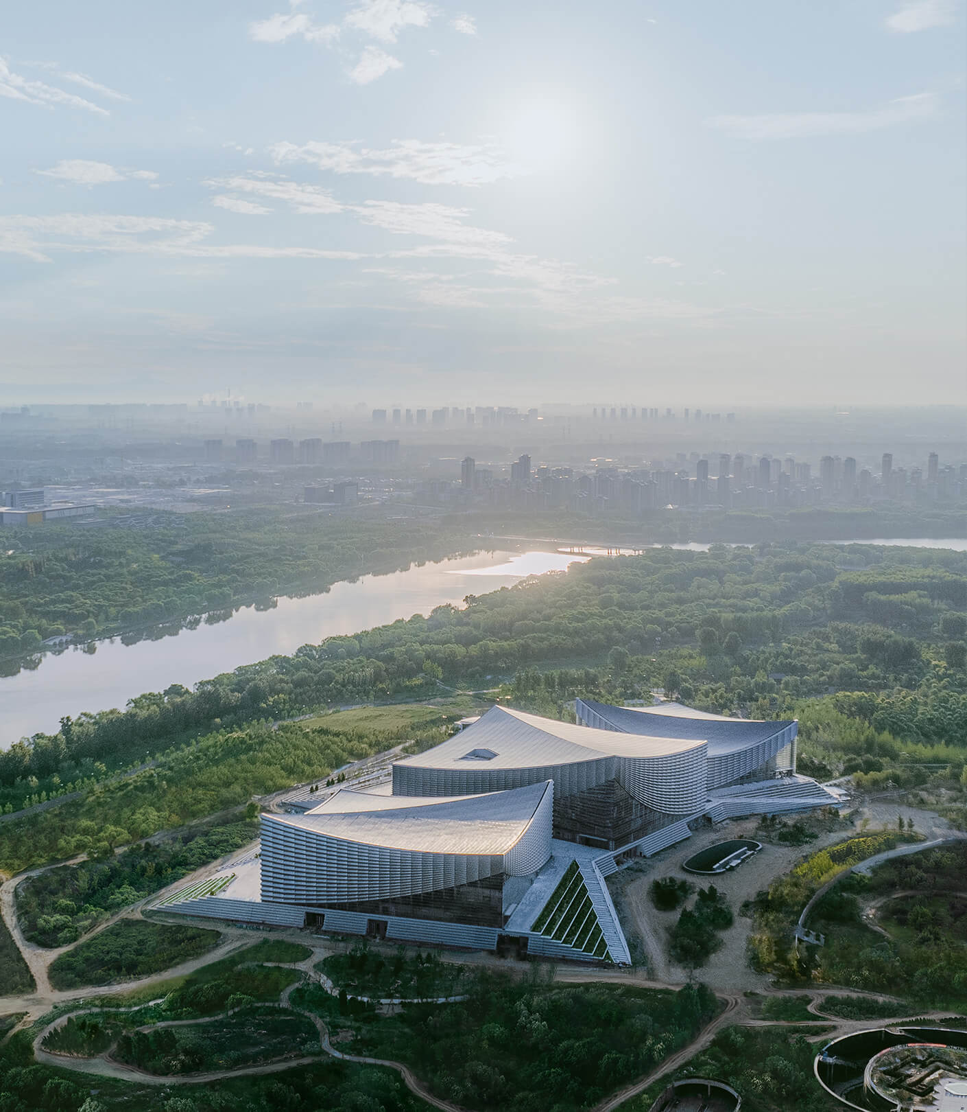

* + **Featured Projects quick links**
    - **Heading:** Featured work
    - **Project 1 Title:** Glassline Residence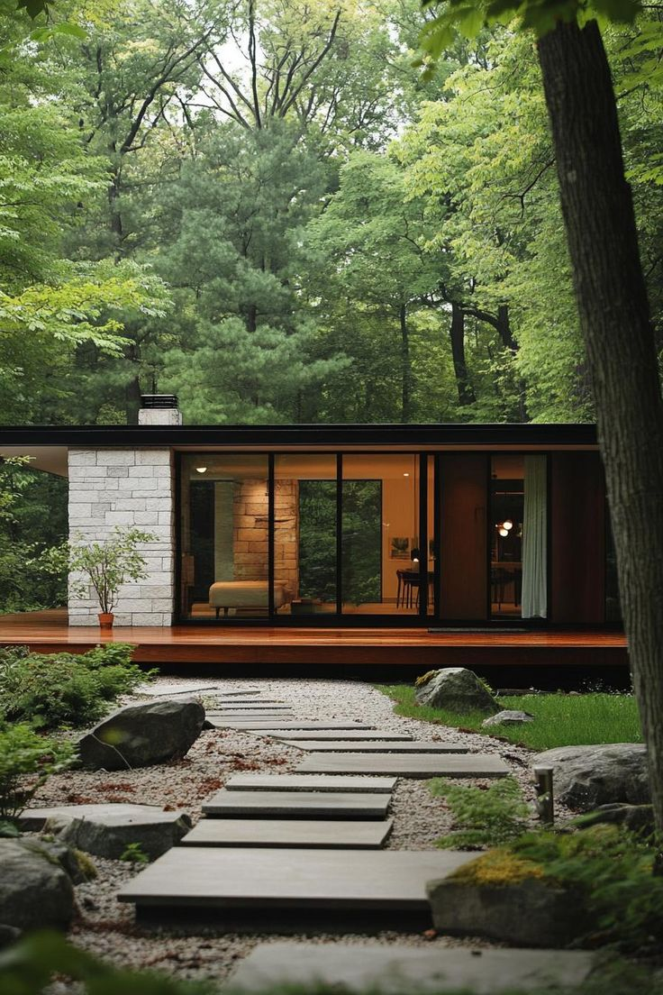
    - **Project 2 Title:** Urban Haven Loft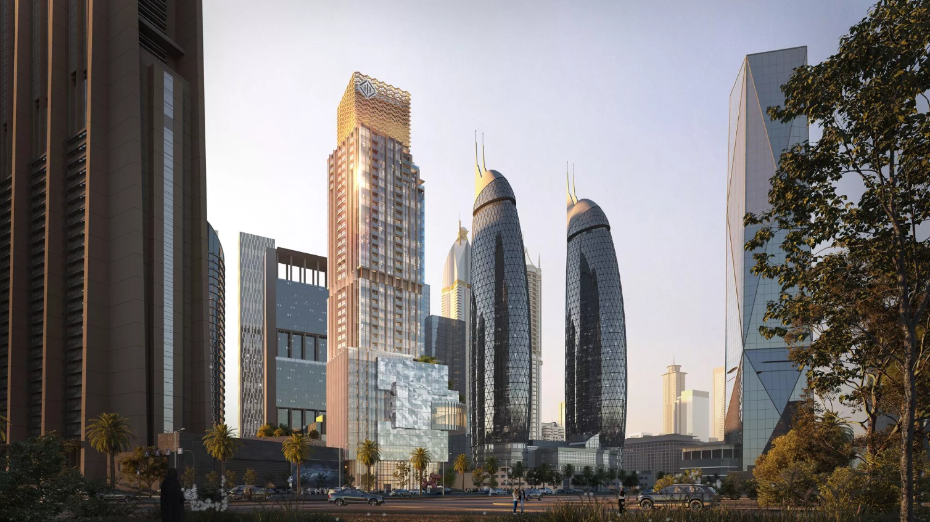
    - **Project 3 Title:** Axis Tower office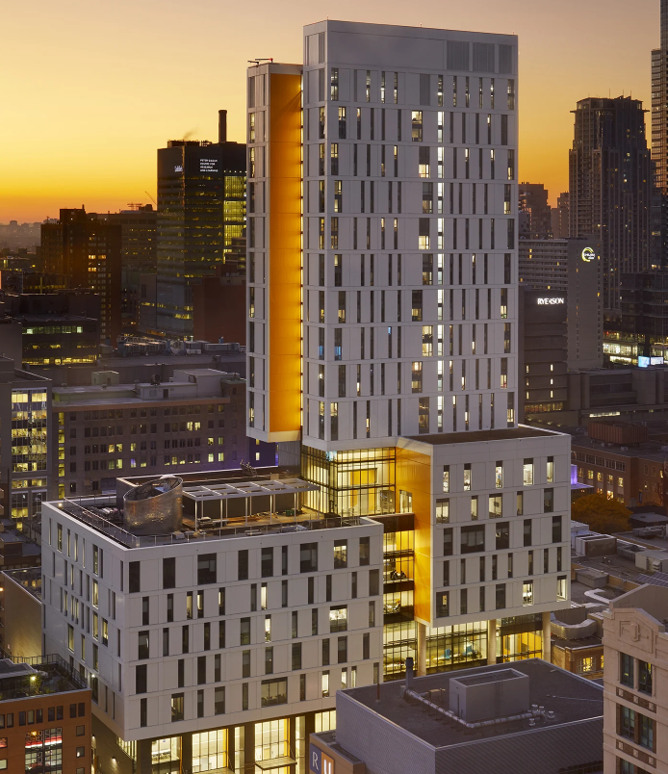
    - ***(Each tile links to the projects page)***
  + **Footer CTA**
    - **Heading:** Ready to build something extraordinary?
    - **Button:** Get in Touch
* **Design Process / Philosophy Page**
  + **Intro header:** Our process
  + **Paragraph:** From initial vision to final detail, our process ensures every project at Axis Design is thoughtfully curated. We partner with clients to navigate each phase—from discovery to realization—making sure design, function and sustainability are aligned.

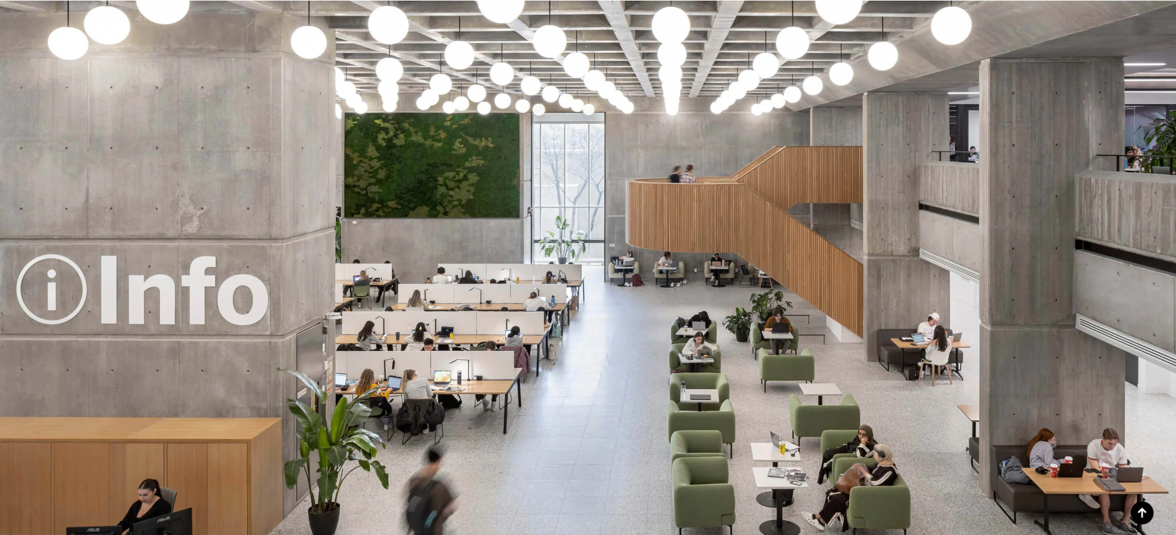

* + **Steps section:**
    - **1. Discovery** — We begin by listening: understanding your goals, context and constraints.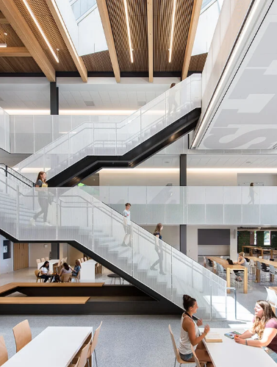
    - **2. Concept** — We explore form, light, materials and structure to shape the overall vision.  
      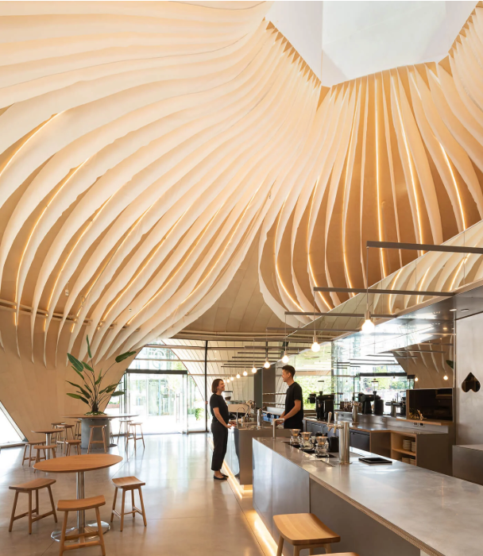
    - **3. Refinement** — We fine-tune the details: material selection, energy efficiency, and human scale.  
      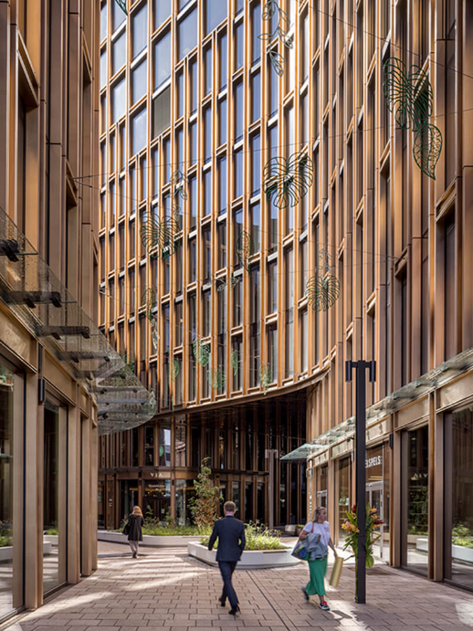
    - **4. Realization** — We oversee execution and ensure quality, timing and sustainability deliverables.

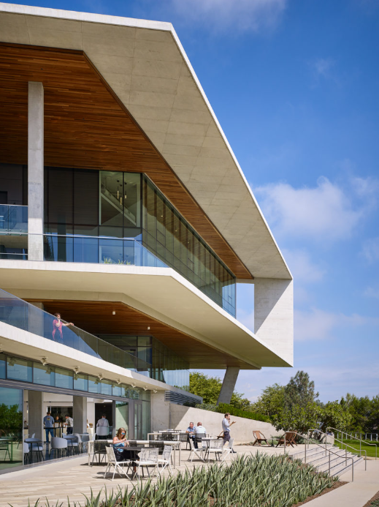

* + **Design Philosophy Block:**
    - **Heading:** Our Philosophy
    - **Paragraph:** We believe great architecture emerges where bold ideas meet responsible design. We fuse clean geometry, natural materials and cutting-edge technologies to create spaces that stand the test of time. Form follows purpose—and people matter most.
* **Projects page**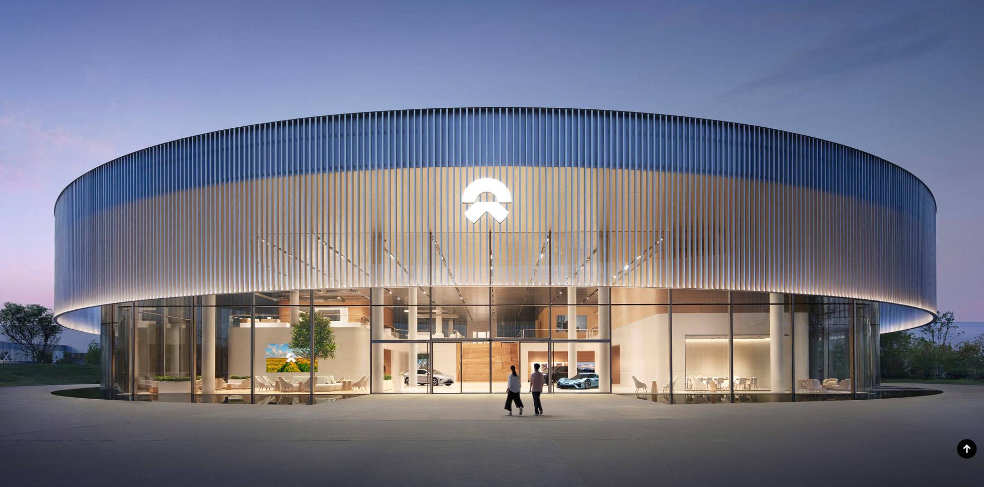
  + **Heading:** Our Work
  + **Sub-heading:** A selected portfolio of modern, sustainable architecture
  + **Project grid:**
    - **Glassline Residence** – A minimalist glass-and-wood hillside home that maximizes daylight and views.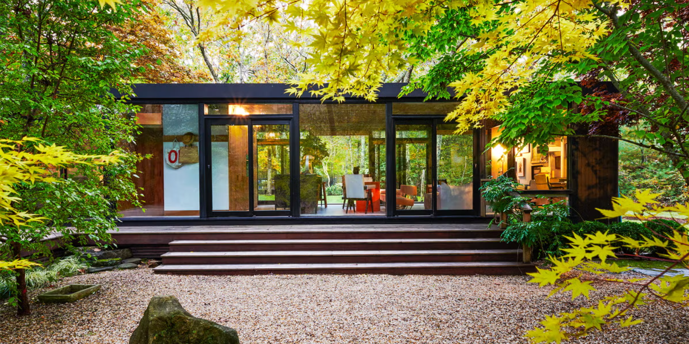
    - **Urban Haven Loft** – Adaptive-reuse loft space in the city, blending industrial heritage with sleek modern finishes.
    - **Axis Tower Office** – A high-rise office redevelopment using green roofs, high-performance façade and open-plan collaborative zones.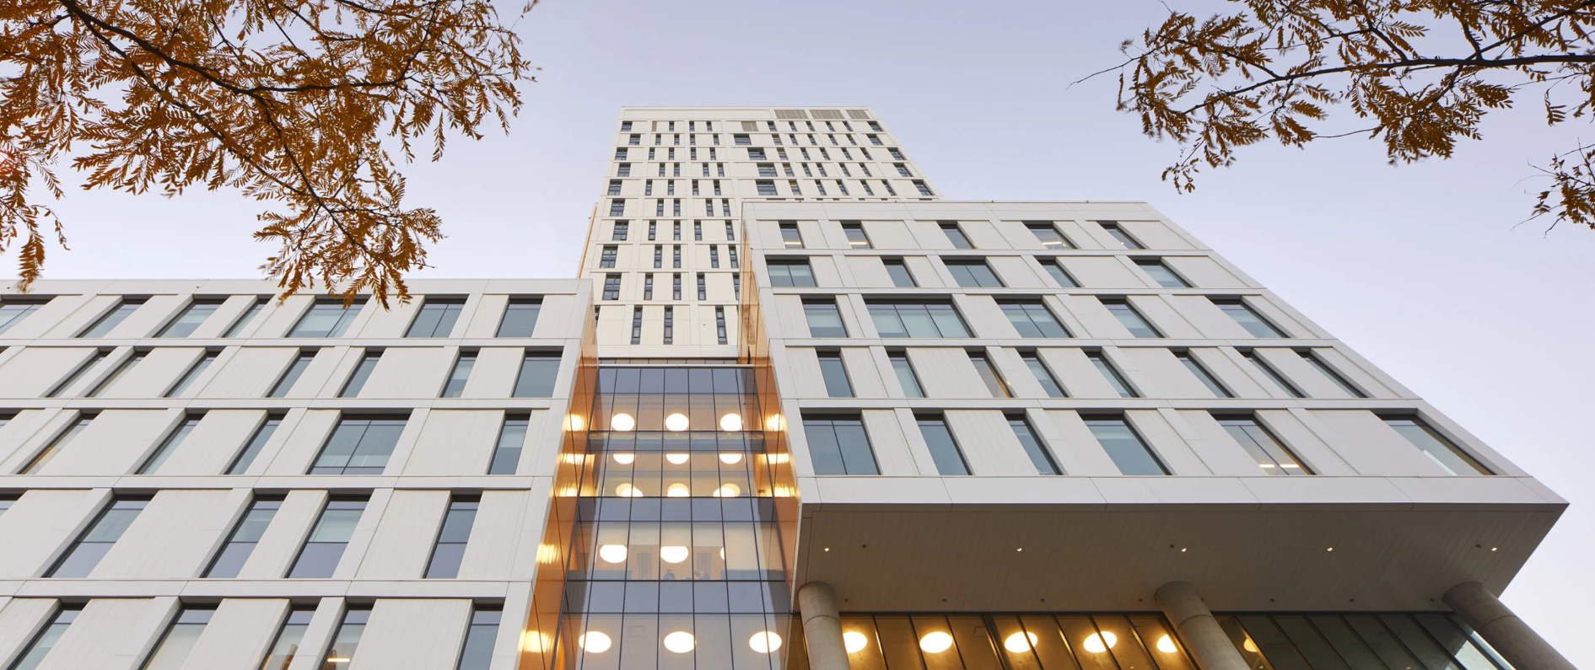
* **Contact CTA at bottom:**
  + **Heading:** Interested in working with us?
  + **Button:** Let’s Talk

Wireframes

### Home

<https://wireframe.cc/z8LCz5>

### Design Philosophy page

<https://wireframe.cc/mF8rwQ>

### Projects Page

[https://wirefram e.cc/ldkj6t](https://wireframe.cc/ldkj6t)